**Examination Enquiry Chatbot**

END TERM REPORT

***by***

**J.Jeetendranath**

(Section: K18KY)

(Roll Number:02)

(Reg no:11802983)

**V.Mohithvenkatasai**

(Section: K18KY)

(Roll Number:33)

(Reg no:11802939)

**K.Khusheeswar**

(Section: K18KY)

(Roll Number:01)

(Reg no:11802921)

**N.Vamsikrishnareddy**

(Section: K18KY)

(Roll Number:28)

(Reg no:11802965)

***Submitted to***

**Shabnam Madam**



**Student Declaration**

This is to declare that this report has been written by Jeetendra,Mohith,kusheeswar and vamsi. No part of the report is copied from other sources. All information included from other sources have been duly acknowledged. I/We aver that if any part of the report is found to be copied, I/we are shall take full responsibility for it.

J.Jeetendranath

K18KY

RollNo:02

V.Mohith

K18KY

RollNo:33

K.Khusheeswar

K18KY

RollNo:01

N.Vamsi

K18KY

RollNo:28

Place:Visakhapatanam

Date:10-04-2020

BONAFIDE CERTIFICATE

Certified that this project report “……….Examimation enquiry Chatbot… ” is the

bonafide work of “J.Jeetendra,V,Mohith,K.Khusheeswar,N.Vamsi ” who carried out

the project work under my supervision.

## Table of Contents:

|  |  |
| --- | --- |
| **Topics** | **Page No:** |
| Abstract | **5** |
| Introduction | **6-12** |
| Code | **13-18** |
| References | **19** |

**Abstract**

“A **chatbot** (also known as a **talkbot**, **chatterbot**, **Bot**, **IM bot**, **interactive agent**, or **Artificial Conversational Entity**) is a computer program or an artificial intelligence which conducts a conversation via auditory or textual methods. Such programs are often designed to convincingly simulate how a human would behave as a conversational partner, thereby passing the Turing test. Chatbots are typically used in dialog systems for various practical purposes including customer service or information acquisition. Some chatterbots use sophisticated natural language processing systems, but many simpler systems scan for keywords within the input, then pull a reply with the most matching keywords, or the most similar wording pattern, from a database.

Since the time chatbots have entered the digital world. Every marketer is curious to use them as a major tool to daily interact with their customers. Our program will useful for this type of purposes with the interaction with students who are having having doubts about the university examinations.

# Introduction

## Motivation:

Our motive is to solve the doubts from the students and to solve the queries regarding the examination in the college.

Now-a-days there are no efficient chatbots for colleges to solve the queries of the students.

Regarding the issue we had taken this project.

Our chatbot can solve the queries of the students regarding the examination process.

## Aim

The aim of the project is to develop a college examination enquiry chatbot using Artificial Intelligence in python programming.

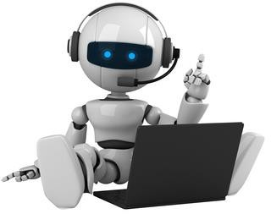

## Objectives

A chatbot is an artificial intelligence software that can simulate a conversation with a user in natural language through messaging applications, websites, mobile apps or through the telephone.

## Why Chatbots are important ?

A chatbot is often described as one of the most advanced and promising expressions of interaction between humans and machines.

However, from a technological point of view, a chatbot only represents the natural evolution of a Question Answering system leveraging Natural language processing (NLP).

Formulating responses to questions in natural language is one of the most typical Examples of Natural language processing applied in various enterprises end use applications.

## Benefits of chatbot’s :

We added few more points to categorize benefits of chatbots clearly:

### Benefits for customers:

**24-hour availability:**

While this is clearly a huge benefit highlighting this risk creating backlash when bots are down due to security issues or maintenance

### Instant Answers :

When we ask a query chatbot gives the answers instantly related to the query.

### End-less patience :

While customers reps and customers sometimes lose their patience that something bots are yet incapable of.

### Instant Transactions :

Actions like changing or querying records are almost instantaneous for bots.

### Benefits to Companies :

**Improved customer satisfaction:**

All the benefits above will result in increased customer satisfaction which can lead to increased customer advocacy and sales.

### Cost Savings:

Companies need for growing the customer service department can be managed by rolling out increasingly capable bots handling more and more complex queries.

### Reaching new customers:

Bot platforms such as Facebook messenger are one of the most popular apps.

Being continuously active on these platforms helps companies reach new customers who may otherwise not want to reach out to the company with an e-mail or call.

### Gaining a deeper understanding of understanding of customers:

Your customers are rarely talk to your business.

Chatbots provide your business with detailed actionable records of your customers greatest pain points, helping your company improve its products and services.

## Future scope of Chatbots:

It would be wrong or ignorant to say that chatbot is evolving and their evolution will become complete in 2020

Chatbots evolved in 2018 and are more intelligent as well as humans than ever.

The successful adoption of chatbots by end-users has led to use of more and more bots in advanced artificial intelligence technologies.

Even there are reports that 80-85 % of business will be deploying advanced chatbots by 2022.

### Probable trends of Chatbot Giving Humanlike experience

If you are talking about personalized customer experience and

offering services which are like the ones provided by humans

The advancement in artificial intelligence and machine-learning in todays era has made chatbot services more like human-like and even impeccable.

### AI chatbot apps:

Speaking of desktop and mobile apps, the ones whose interface is powered by AI and processed by chatbots.

.

### Developing NLO tech for automated calls:

It simply serves as a boon for automated call centers

This technology is so advanced that the best failure is the absence of downtime.

Serving a wide range of customer base all around the day and that too without any hassles is what the NLO is designed for and it can help in solving the problems 24/7

### Suited virtual assistants:

In today’s era, many smart phone users are simply downloading these types of apps for getting virtual assistance.

It is easier to use applications now and the automation of any kind related to customer service is simply possible.

This is due to the ability of chatbots to combine many applications into a single task that can accelerate the development and growth of a business.

## Faster problem solving:

If you really want faster clarifications for your various queries, it is easy.

You can achieve that by using handheld devices like tablets

,smartphones and wearables such as smart watches. In addition, smart tv are becoming one of the major integrations for voice assistants like Siri, Alexa, Google assistant.

## NLP for chats (Interactive ones):

Natural Language Programming helps in giving an enhanced human experience , thereby making the chatbots more interactive

No doubts , chatbots are a great help for e-commerce stores where most of the customer issues can be filtered and move them to various consumers for clarifying their doubts.

With chatbots we know where things are heading to the future

For AI and Chatbot, the future is coming one way or another, and that can’t be avoided.

# Code

from tkinter import *

root=Tk()

def chatbot():

send=e.get("1.0",'end-1c').strip()

e.delete("0.0",END)

if send != '':

txt.config(state=NORMAL)

txt.insert(END, "You: " + send + '\n')

txt.config(foreground="white", font=("Verdana", 8 ))

j=send.split()

k=len(j)

#print(j)

for l in range(0,k):

if(j[l]=="hi" or j[l]=="hello" or j[l]=="hey"):

txt.insert(END,"\n"+"BOT:Hello!, I am here to solve your examination quaries.\n\n")

for l in range(0,k):

if(j[l]=="examination" or j[l]=="exam" ):

for m in range(0,k):

if(j[m]=="conducted"):

txt.insert(END,"\n"+"BOT:Exams are conducted by lpu examination department.\n\n")

for l in range(0,k):

if(j[l]=="examination" or j[l]=="exam"):

for m in range(0,k):

if(j[m]=="date"or j[m]=="dates"):

txt.insert(END,"\n"+"BOT:exams are from 29-04-2020 to 13-05-2020.\n\n")

for l in range(0,k):

if(j[l]=="examination" or j[l]=="exams"):

for m in range(0,k):

if(j[m]=="from" or j[m]=="starting from"):

txt.insert(END,"\n"+"BOT:exams are from 29-04-2020.\n\n")

for l in range(0,k):

if(j[l]=="examination " or j[l]=="exams"):

for m in range(0,k):

if(j[m]=="till" or j[m]=="ending" or j[m]=="end" or j[m]=="ends"):

txt.insert(END,"\n"+"BOT:exams are from 13-05-2020.\n\n")

for l in range(0,k):

if(j[l]=="examination"):

for m in range(0,k):

if(j[m]=="instructions"):

txt.insert(END,"\n"+"BOT:You can find examination instruction in UMS \n Follow the path UMS navigation -> Examination -> Examination Queries.\n\n")

for l in range(0,k):

if(j[l]=="examination instructions" or j[l]=="instructions"):

for n in range(0,k):

if(j[n]=="for"):

for m in range(0,k):

if(j[m]=="exams" or j[m]=="examination"):

txt.insert(END,"\n"+"BOT:You can find examination instruction in UMS \n Follow the path UMS navigation -> Examination -> Examination Queries.\n\n")

for l in range(0,k):

if(j[l]=="seating"):

for m in range(0,k):

if(j[m]=="plan" or j[m]=="arrangement"):

txt.insert(END,"\n"+"BOT:It will be available in your alloted examination class.\n\n")

for l in range(0,k):

if(j[l]=="examination" or j[l]=="exam"):

for m in range(0,k):

if(j[m]=="timings" or j[m]=="classroom"):

txt.insert(END,"\n"+"BOT:It will be uploaded on ums->seating arrangements or it will be available on lpu touch exams available.\n\n")

for l in range(0,k):

if(j[l]=="exam"):

for m in range(0,k):

if(j[m]=="pattern"):

txt.insert(END,"\n"+"BOT:It is based on the course.you can available it in the UMS.\n\n")

for l in range(0,k):

if(j[l]=="grades"):

txt.insert(END,"\n"+"BOT:Grades are given by subject wise.where grade O to D are passed and E grade is reapper,F is fail.you have 5 chances to clear your reappers.\n\n")

for l in range(0,k):

if(j[l]=="doubts" or j[l]=="discrepency"):

for n in range(0,k):

if(j[n]=="in"):

for m in range(0,k):

if(j[m]=="exams" or j[m]=="examination"):

txt.insert(END,"\n"+"BOT:There was a discrepancy form with invigilator there you need to fill your doubts in the question paper.\n\n")

for l in range(0,k):

if(j[l]=="eligible"):

for n in range(0,k):

if(j[n]=="for"):

for m in range(0,k):

if(j[m]=="exams" or j[m]=="examination"):

txt.insert(END,"\n"+"BOT:Students whose attendence is above 75% are eligible for examination.\n\n")

for l in range(0,k):

if(j[l]=="contact"):

for m in range(0,k):

if(j[m]=="details"):

txt.insert(END,"\n"+"BOT:Here is our contact numbers:\n9986523741\n7894561235.\n\n")

for l in range(0,k):

if(j[l]=="bye"):

txt.insert(END,"\n"+"BOT:Hope your queries are cleared and if you any further doubts you can visit block no:30 \n All the best for your exams from LPU chatbot.\n\n")

txt=Text(root)

txt.grid(row=0,column=0,columnspan=2)

root.geometry("400x500")

root.resizable(width=FALSE, height=FALSE)

e=Text(root, bd=0, bg="white",width="29", height="5", font="Arial")

SendButton = Button(root, font=("Verdana",12,'bold'), text="Send", width="12", height=5,

bd=0, bg="#32de97", activebackground="#3c9d9b",fg='#ffffff',

command=chatbot)

root.title("LPU EXAMINATION QUERIES")

txt = Text(root, bd=0, bg="black", height="8", width="50", font="Arial",)

txt.config(state=DISABLED)

scrollbar = Scrollbar(root, command=txt.yview, cursor="heart")

txt['yscrollcommand'] = scrollbar.set

scrollbar.place(x=376,y=6, height=386)

txt.place(x=6,y=6, height=386, width=370)

e.place(x=144, y=401, height=90, width=265)

SendButton.place(x=6, y=401, height=90)

root.mainloop

Data sets that contain the queries of the students and answers regarding for that.

Making two arrays to store the data for each statement and the answer for each data is stored in the array

**Output:**

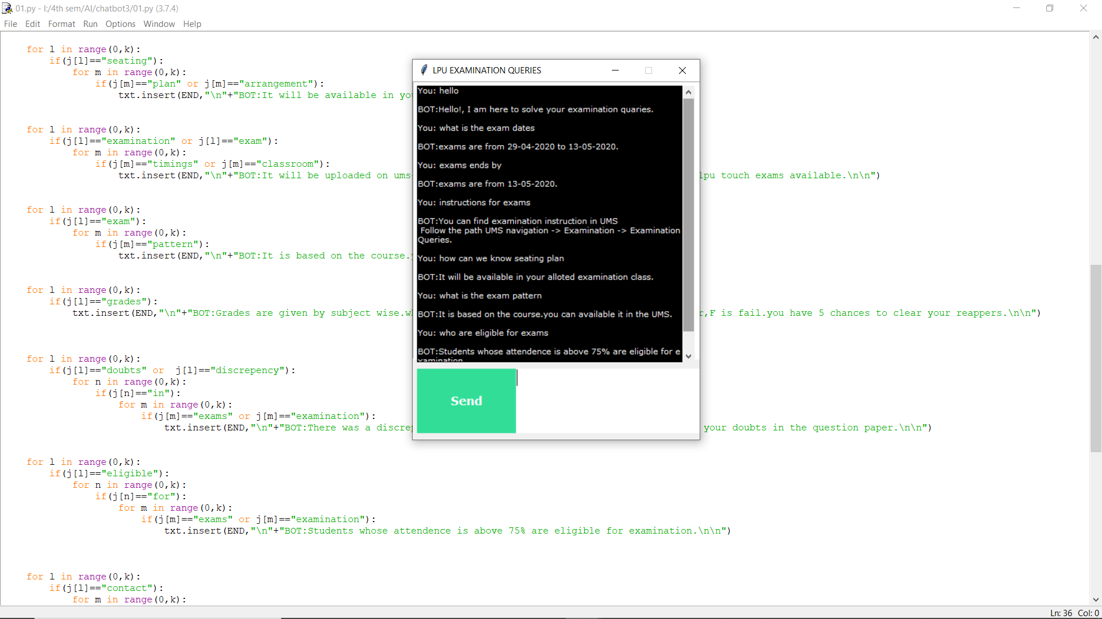

This is the GUI interface that deals with the chatbot answers and it is used by the end user

We divided the work on equal basis and both of us(Jeetendra and mohith) of us gave the data set in two of the programs and half of the report was done by vamsi and another half done by kushieswar and four of us discussed the logics that implemented code.

And project was already uploaded in GITHUB under one repository

Link of the project in Git Hub:

<https://github.com/jeetendranath/chatbot/tree/master>

Link of the project video in loom app:

https://www.loom.com/share/d8a1d2d39bf540808957093a94e2ddef

**References**

[www.lifechatbots.com](http://www.lifechatbots.com/) [www.dataflairtraing.com](http://www.dataflairtraing.com/)

Textbook: Building chatbots with Python.